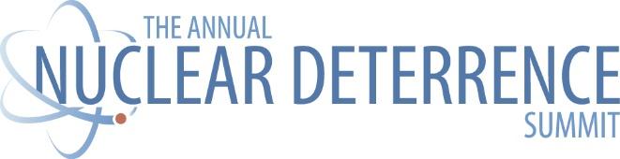
Justification Letter — Government Attendee

Subject: Request to Attend the 2026 Nuclear Deterrence Summit (Jan 26–28, 2026 Arlington, VA)
To:
From:
Date:
Request
I request approval to attend the 2026 Nuclear Deterrence Summit (Jan 26–28, Crystal Gateway Marriott, Arlington, VA). The program centers on accelerating mission capability—faster weapons production, stronger site readiness, and risk-informed execution—and convenes counterparts from DOE/NNSA, DoD, national labs, sites, and industry.
Why this is mission-critical now
- Focus on aligning requirements, risk-based decisions, and agile practices to speed capability delivery while maintaining safety and quality.
- Updates and perspectives from NNSA leadership, field offices, labs, and production sites that inform FY26–FY27 planning and oversight.
- Working sessions and networking designed for practical coordination across policy → program → plant.
Anticipated takeaways (subject to final agenda and speaker availability)
- A clearer view of enterprise priorities and how they could affect our schedules, surety posture, and reporting expectations.
- Practical approaches shared by peers and site leaders for accelerating delivery while managing risk.
- Expanded contacts across HQ, field, labs, sites, and acquisition to expedite issue resolution.
- Notes sufficient to brief leadership and inform near-term planning and coordination.
Cost (Not-to-Exceed)
- Registration: ${{amount}}
- Travel: ${{estimate}}
- Lodging/Per Diem (GSA): ${{estimate}}
- Total NTE: ${{total}}
(Attendance will comply with ethics, travel, and training policies; no gifts or exclusive benefits are offered.)
Time away / Coverage
{{#}} workdays on site; coverage by {{colleague/team}}.
Return on Investment
First-hand guidance and targeted coordination are expected to reduce ambiguity, derisk schedules and interfaces, and improve execution on mission priorities in FY26–FY27.
Respectfully,
{{Your Name • Title • Office • Email • Phone}}

