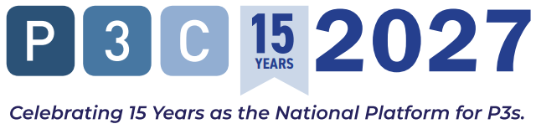
REGISTRATION JUSTIFICATION — PUBLIC AGENCY / GOVERNMENT
15th Annual P3 Conference & Expo · March 15–17, 2027 · Dallas, TX

[[Date]]

[[Supervisor / Budget Approver Name]]
[[Title]]
[[Agency / Department]]

Re: Request for Approval — P3 Conference & Expo, March 15–17, 2027, Dallas, TX
Dear [[Supervisor Name]]:
I am writing to request approval to attend the 15th Annual P3 Conference & Expo (P3C 2027), taking place March 15–17, 2027 at the Sheraton Dallas Hotel in Dallas, Texas. P3C is the national conference for public officials and project owners exploring how public-private partnerships can help fund, build, finance, operate, and maintain essential infrastructure. It is the only event in the country that brings 750+ delegates and 100+ unique public agencies together for this specific purpose, with 35% of all attendees from government and public agencies.
Why This Conference Is Relevant to Our Work
Our agency is currently [[describe current challenge, project, or procurement consideration — e.g., 'evaluating P3 as a delivery model for [Project Name]' or 'facing infrastructure funding gaps that require alternative financing strategies']]. P3C 2027 is built precisely for public officials in this position.
Attending will allow me to:
- Hear directly from commissioners, secretaries, and executive directors at peer agencies who have closed P3 transactions — including what they would structure differently and how they managed procurement risk
- Access federal funding intelligence from senior USDOT, FHWA, and Build America Bureau officials on TIFIA, WIFIA, Private Activity Bonds, and other credit programs directly relevant to our project pipeline
- Participate in pre-scheduled 1-on-1 meetings with developers, investors, legal advisors, and financing teams whose capabilities align with our upcoming procurements — structured introductions confirmed before I arrive
- Understand how current market forces — interest rate shifts, federal funding changes, construction costs — affect the financial feasibility of P3 delivery for projects like ours
- Explore case studies across transportation, water, energy, higher education, and social infrastructure from agencies that have addressed the same funding and delivery pressures we face
Estimated Cost of Attendance
As a government / public agency representative, I qualify for the significantly discounted registration rate — one of the most affordable conference registrations available in the infrastructure sector:
A completed cost worksheet is attached to this request for your review.
What I Will Bring Back
Within five business days of returning, I will deliver a written debrief to [[leadership / your name]] covering:
- A summary of how peer agencies are structuring P3 procurements relevant to our project pipeline
- Intelligence on federal credit programs and financing tools applicable to our upcoming projects
- A contact list of private-sector developers, advisors, and financiers met through pre-scheduled 1-on-1 meetings
- Specific recommendations for how to apply what I learned to [[project or initiative]]
- Certificate of attendance for professional development records

I am committed to making this investment productive for our agency. I am happy to discuss any questions about the conference or the attached cost worksheet. Thank you for your consideration.
Respectfully,

[[Your Name]]
[[Your Title]]
[[Agency / Department]]
[[Phone | Email]]
Attachment: P3C 2027 Cost Worksheet · Questions: Beth Wagner · bwagner@accessintel.com · Register: accessintel.swoogo.com/p3c27

